Why is it that so many different illnesses have been reportedly Treated although seemingly mysteriously with Pulsed Electro magnetic therapy( PEMF)? Professor Holger Hannemann of Switzerland states: "This is now easy to understand when you keep in mind that many illnesses are the result of the same basic dysfunction. Every illness is a bio-energetic (electrical) breakdown of the organism. It is a sign that the cells have been deprived of energy and the defense mechanism weakened. It is then the task of Pulsed Electro magnetic therapy( PEMF) to remove the blockages that get in the way of normal functioning."
All energy is electromagnetic in nature. All atoms, chemicals and cells produce electromagnetic fields (EMFs). Every organ in the body produces it own signature bioelectromagnetic field. Science has proven that our bodies actually project their own magnetic fields and that all 70 trillion cells in the body communicate via electromagnetic frequencies. Nothing happens in the body without an electromagnetic exchange. When the electromagnetic activity of the body ceases, life ceases.
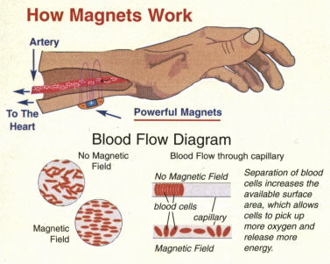
Increasing blood flow and oxygen to all areas of the body; Increased blood flow produces higher levels of the anti-inflammatory white blood cells and the more densely oxygen saturated red blood cells to the damaged areas, whilst at the same time removing toxins more readily which can often can also be a cause of pain. Result the healing process is more efficient.
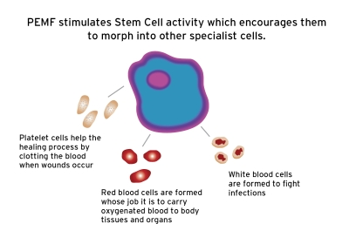
The purpose of this Newsletter is to provide a basic understanding of how magnetic fields, especially PEMFs, work in the body. In addition to these basic balancing actions, magnetic fields also help with many other functions and conditions, and new ones are discovered regularly.
Some of these other actions include:
reducing muscle tension
improving tissue healing
reducing pain
increasing energy
improving clotting factors
slowing the development of arthritis
stimulating the immune system
helping the body to detoxify
improving the uptake of nutrients
reducing blood pressure
helping nerve function
helping liver function
balancing the acupuncture meridians
improving sleep
making soft tissue more flexible
reducing arthritic changes
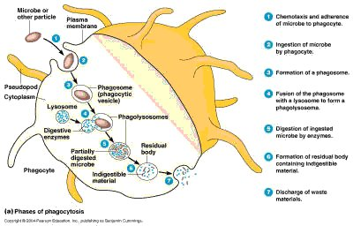
When a magnetic field is present in the blood, toxins in the tissues are drawn out as the magnetized blood passes through the tissues. The toxins are then carried to the liver for detoxification and on to the kidneys for excretion.
The science of Magnetherapy indicates that 2 vital things happen when PEMF applied to the skin:
First, the soft tissue will lengthen and will help to relax a muscle or ligament that is damaged or traumatised. It will work in an area and depth directly proportional to the type and strength of the PEMF used. Depending on the strength, you can effect a change to a radius of between 3-5 inches and to a similar depth.
Secondly, as the tissue relaxes, more oxygen and blood flow is able to gain access to the damaged site, and so it enters the damaged area with increasing magnitude. This effect can be seen using thermal imaging techniques.
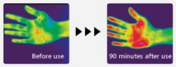

Increased Circulation
One of the most basic functions magnetic fields have in the body is to increase circulation. When a cell (such as a red blood cell) is injured or ill, it does not hold its ideal charge. This causes red cells to “stick” together, making circulation slow.
Red blood cells respond to pulsed electro magnetic fields (PEMF)
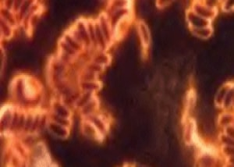 | Before PEMF Therapy  This is what is known as the "coinroll formation" effect, where strings of red blood cells stick together. This greatly reduces the available surface area of the red blood cells and in turn their capacity to absorb oxygen and nutrients to transport around the body.
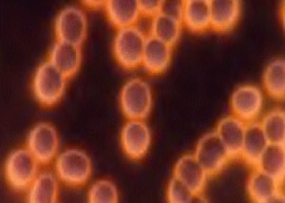 | After PEMF Therapy  They have now separated and are free to absorb more oxygen and take on more nutrients to transport around the body. This means that they can take the maximum amount of oxygen from the lungs and nutrients to the cells in the body,particularly those in need of regeneration and repair and remove toxins and carbon dioxide more efficiently.
When a PEMFpasses through the red cell, the membrane becomes properly charged, allowing the cell to repel itself and keep itself separate from other red cells, thereby increasing circulation. In addition, PEMFs increase various chemicals in the blood vessel walls that cause the blood vessels to dilate, improving the amount of blood flowing through the vessels and therefore increasing the amount of oxygen delivered to the tissues.
When a magnetic field is placed over a blood vessel, the influence of the field will cause positive and negative ions (for example, Na+ and Cl-) to bounce back and forth between the sides of the vessel, creating flow currents in the moving blood not unlike those in a river. The combination of the electromotive force, altered ionic pattern, and the currents causes blood vessel dilation with a corresponding increase in blood flow. 31
Poor circulation makes tissues unhealthy and prone to disease and breakdown. Improved circulation helps tissues get the nutrition and oxygen they need, while expelling the waste they produce. Good circulation helps with tissue healing and regeneration. The result of improved circulation is the reduction of swelling and the removal of bruising.
The following symptoms can indicate poor circulation of the legs, or :peripheral arterial disease
Wounds that heal slowly or poorly
Legs that are cooler in temperature than arms
Skin on your legs that is shiny
Decreased pulses in your feet
Hair loss on legs
Legs that have pain, fatigue, or a feeling of heaviness
Leg muscles that are cramped or uncomfortable

How Do Magnetic Fields Affect Cells?
"All cells in the body share common components, regardless of their type. One of the common constituents of all cells are ions. Ions are positively and negatively charged particles that conduct electro-magnetic pulses from within the cell. The electro-magnetic pulses allow the cell to function. Without ions, a cell can not live.
In a healthy cell, the ions are distributed around the cell with all of the positive ions on one side and the negative ions on the opposing side. The ions which live outside of the cell in the tissues will align with those inside of the cell so that opposing poles are together with the cell membrane between them (see diagram of healthy cell below). This allows fluid, oxygen and nutrients (fluid exchange) to move freely in and out of the cell, while maintaining the natural balance within the cell (homeostasis).
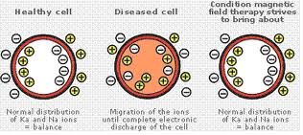
Ionic distribution in healthy cell, diseased cell, and magnetic influenced cells
In a diseased (injured) cell, the positive and negative ions do not stay on opposing sides of the cell. They are disrupted and scatter randomly around the cell. At the same time the ions on the outside of the cell membrane also become scattered as they try to find their opposing pole, this results in cellular imbalance. Extra fluid from the tissues outside the cell is able to penetrate the cell which in turn pushes vital nutrients, hormones and electrolytes (salts) out of the cell. The cell's ability to function is greatly reduced and cellular degeneration begins, which if not corrected will lead to the cell dying.
When a pemf is applied over an injured (dis-eased) area, the magnetism penetrates into the tissues and surrounds the damaged cell. The magnetic field that is created around the outside of the cell will pull the ions, both inside and outside, back into alignment. The result is that the ions once again return to their correct position within the cell. The extra fluid that has penetrated the cell is pushed out (via osmosis and diffusion) and returned to the surrounding tissues. The cell regains its natural healthy balance and any damage is repaired over a period of days (see diagram of a cell with a magnetic field)
Decreased Inflammation
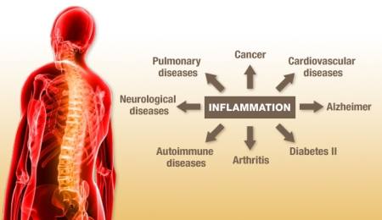
Decreased Inflammation
Normally an injured site, whether from arthritis, torn muscles or any other condition, will be surrounded by inflammation. This can comprise of lactic acids, calcium and other deposits. Basically the site is ‘hot’ with acidity. The increases in oxygen and blood flow brings with it increased alkalinity. This neutralises the acidity, allowing the body to re-commence its own healing abilities. Magnets merely encourage this in a truly dramatic way.
Inflammation is a physiologic processes initiated by the body to repair cellular damage in tissues by increasing the blood flow to the damaged area and increasing the number of good cells. The process of inflammation is generated and supported by the interaction of a number of immune cell types, with other cell types (like T cells) playing a regulatory role in the effect. Inflammation is a necessary and beneficial process, but it often persists longer than necessary, resulting in chronic inflammation. PEMFs have been found to reduce chronic, damaging inflammation..
"NASA has invest $3.5 million into four years of magnetic therapy studies
What did NASA’s studies conclude? Magnetic therapy is effective in healing refractory broken bones — bones that are unable to heal despite repeated surgical procedures. NASA also found magnetic therapy is successful in developing tissues for transplantation, repairing traumatized tissues, and moderating some neurodegenerative diseases such as Parkinson’s and Alzheimer’s. Lastly, previous studies also suggest that PEMF might be useful in the treatment of some muscle disorders."
Magnetic therapy doesn’t just benefit astronauts
Clearly, magnetic therapy doesn’t just benefit astronauts. As NASA research concluded: On earth, this device is effective in the treatment of various muscle diseases, age- and cancer-related muscle atrophy, osteoporosis and other bone diseases. Currently, the Food and Drug Administration has cleared magnetic therapy for fusing broken bones, treating severe untreatable depression, and post-operative pain and swelling."
In bacterial infections, early infiltration of the affected tissues by white blood cells is followed by the arrival of T cells, which kill bacteria. In this circumstance, eliminating of T cells can delay or stop healing. Conversely, in trauma-induced injury, T cells are less important to the healing process, and may be harmful if present for too long. In this case, elimination of T cells can minimize the unwanted effects of inflammation, accelerate healing, and reduce the risk of chronic inflammatory diseases. In chronic inflammatory diseases such as rheumatoid arthritis, psoriasis, or tendinitis, T cells support the persistence of the disease state, and removing them would be favorable.
Research shows us that PEMFs can induce the appropriate death of aged, chronic T lymphocytes, by actions on T cell membranes and key enzymes in cells. For example, PEMFs affect ion flow through specific cell membrane channels (like those for sodium, potassium, and calcium), which positively affect these enzymes.
Lymphocytic leukemias (also known as lymphoid or lymphoblastic leukemia) start in the cells that become lymphocytes. Lymphomas are also cancers that start in those cells. The main difference between lymphocytic leukemias and lymphomas is that in leukemia, the cancer cell is mainly in the bone marrow and blood, while in lymphoma it tends to be in lymph nodes and other tissues. Source
Once the tissue area starts detoxifying, the thermal benefits of pemf can begin. As the blood in our body continuously circulates, periodically, it comes close to the PEMF placed on the skin above it. In this magnetic field, the ions in the blood become agitated and are attracted to the magnet. As a result, atomic particles begin to spin inside the cell (known as ‘The Hall Effect’).
This ‘switching-on’ causes the body to stimulate its own beta-endorphin
Some doctors prefer only North Pole, whereas others prefer South Pole for treatment. Dr Albert Roy Davis, U.S.A. is an ardent supporter of single pole use in his treatment. His book ‘the Anatomy of Bio-magnetism’ states: Treatment indications
Detoxification is among the multiple benefits associated with PEMF. Through Dr. Bonlie’s years of research and experience, he has found that the increased negative magnetic field produced by magnetic fields assists your body in expelling environmental toxins. You will be amazed at the renewed energy and symptom relief you will experience once your body is free of this environmental “sludge”.
Most toxins have a Positive (+) charge. The increased Negative (-) energy from PEMF passes through all the cells of your body, thereby assisting the release of toxins and waste products.
In order for your body to expel most of these toxins, they must be filtered through your lymphatic system, passed through your liver and kidneys, and finally excreted in your urine.
Magnetic water remains a little known treatment in the field of magnetic therapy, plus there is always much speculation as to the validity of magnetizing water. Despite this skepticism, magnetic water remains one of magnet therapies most powerful treatments. Many scientists and doctors profess that it is impossible to magnetize water, that water quite simply can not hold a magnetic charge. Our answer to these people is... do a little more scientific research and you will find that all water in it's natural state (such as a spring) has a magnetic charge.
Just Place your glass of water on the PEMF units paddle for 20 mins
The following biological and therapeutic functions have already been identified and verified by experiment:
"It can prevent damage to the endothelium (the layer of scale like cells that line the inside of the blood and lymph vessels, also found in the lining of the heart and some other body cavities. This has the effect of inhibiting the build up of cholesterol, thereby greatly reducing the chances of cerebral and cardiac arteriosclerosis (thickening and hardening of the arteries)."
"Magnet Therapy with Burton Goldberg"
PEMFs address impaired chemistry and thus the function of cells – which in turn, improves health. PEMFs deliver beneficial, health-enhancing EMFs and frequencies to the cells. Low frequency PEMFs of even the weakest strengths pass right through the body, penetrating every cell, tissue, organ and even bone without being absorbed or altered! As they pass through, they stimulate most of the electrical and chemical processes in the tissues. Therapeutic PEMFs are specifically designed to positively support cellular energy, resulting in better cellular health and function.
Having healthy cells is not a passive process. Active, regular tuning-up of our cells is not only feasible, but also necessary to slow aging and reduce the risk of cell dysfunction. We are, after all, only as healthy as our cells. Imperceptible cell dysfunction that is not corrected early can lead to disease. Fine-tuning can be done daily in only minutes, using pulsed electromagnetic fields (PEMFs). In addition, when there is a known imbalance (when symptoms are present) or there is a known disease or condition, PEMF treatments, used either alone or along with other therapies, can often help cells rebalance dysfunction faster.
With PEMF therapy, it must be remembered that it is also necessary to drink at least 3-4 glasses of water a day, which is required to flush from your system the toxins that are being released from the cells.

Welcome to ‘Natural Body Healing’
We are what we eat and drink; what we feel and what we think. When we feel perfectly healthy - all physical, mental, spiritual and emotional aspects of our life are working in total harmony and balance.
Yet, trying to maintain any equilibrium can indeed be a real struggle these days. We're constantly subjected to external influences such as stress, poor diet, electromagnetic pollution, environmental toxicity and improper lifestyle; all of which can upset our inner equilibrium and cause a severe disruption of balance and energy flow throughout our physical, emotional and mental body.
To eliminate poor health, we therefore should endeavour to take full responsibility for our own bodies and look to adapt our lifestyles, our inner thoughts and emotions, our environment and our diets accordingly, so that our body's general vitality levels and functionality can be restored. If we make these changes, our natural ability to fight off infection and disease will regain proper control which will allow us to 'self-heal'. The human body is such an amazingly capable living being, if given the right external and internal conditions in which to flourish.
For the body to function, we each need oxygen, water, food and exercise. However, for our bodies to function properly, we also need to be surrounded by static electro-magnetic fields to ensure effective communication between our cells and the free-flowing of vital energy. The qualityof each of these 5 elements will determine the state of our own health. By utilising each of these elements, our body can properly coordinate and balance our own internal energy flow, emotions and mind.
The type of food that we put inside our bodies is a key factor as to how our bodies function everyday. The fundamentals for healthy eating are to choose a daily diet based upon foods that are pure, organic, fresh and varied. It’s also essential that you drink plenty of water, keep active, keep your emotions and thoughts positive, exercise regularly and learn to relax and sleep well.
Furthermore, we’d encourage you to keep mentally stimulated through self-development techniques and courses. And importantly, always try to keep positive, surround yourself with supportive friends and family, and make sure you get some fun and laughter in your life!
When you’re healthy and happy, you’re able to cope with stress much better, you experience greater energy levels, you think clearer, you perform better and you have increased flexibility and vitality throughout your body and mind.
At Natural Body Healing, it’s our goal to provide you with useful information on essential health matters that will encourage you to take responsibility for looking after your own body in your quest for well-being.
Apart from offering constructive advice and support, we also provide a growing range of complementaryholistic therapies, powerful products that product against electromagnetic frequencies, in addition to selling 100% natural and organic nutritional supplements that nourish, stimulate and rebalance.
All our products and services encourage your body to work more efficiently and heal naturally, enabling you to enjoy greatly improved health benefits.
Paying much-needed attention to your lifestyle and well-being from today onwards can truly improve your enjoyment and your quality of life now and well into the future; not just for yourself, but also for those around you too. With little effort on your part, you too can enjoy the benefits that positive health can bring.

Research indicates that in general, magnetic therapy works because of the electromagnetic nature of the body. Every cell in our body consists of electrically charged particles that are either positive or negative ions. All are directly affected by exposure to external magnetic fields. PULSED ELECTRO MAGNET FIELDS (PEMF) can affect the body at both microscopic and at overall levels. If the PEMF can be placed to influence a section of blood vessel carrying the fluid flow, then the flow at that place will be improved locally and there will be an improvement in the alignment of the molecules, Magnetic Field Therapy (MFT) is one of the world's oldest forms of healing. The first documented references to MFT in medicine were made over 6000 years ago and make MFT one of the most traditional methods of medical treatment. MFT was used widely for healing by the ancient Greeks, Romans and in particular the Egyptians as well as the highly advanced cultures of Central America. It was central to the medical models of Paracelsius and Messmer. Bio-magnetic healing is a therapy that is now sweeping the US because it helps the body heal itself. Used in ancient Egypt and rediscovered by NASA for the astronauts, magnet therapy has also been successful in providing relief for the complex issues of WRULD.(Repetitive Strain Injury (RSI) is one of the curses of modern technology; Work Related Upper Limb Disorder (WRULD) may be a newer label for the syndrome but the symptoms are the same: pain, numbness, tingling and skin sensitivity)... From clinical experiments, we know that Pulsating Magnetic Fields can reduce pain sensations almost immediately. This is due in part to the increase in the oxygen partial pressure in the terminal tissue and the increase in the local perfusion and velocity of the capillary blood flow alleviating the accumulation of metabolites due to small vascularization and blood flow (transmitted by the sympathetic nervous system). As stated Magnet therapy was used in Ancient Egypt and rediscovered by NASA, lining the astronauts suits to avoid them being adversely affected by removal from the earth's natural magnetic field. Not only does the modern environment shield all of us from much of the natural geomagnetic field, but also research shows that over the last century it has declined 5 per cent. Yet it is fundamental for our health and well being. Iron makes up about 4 per cent of our blood content. Magnets attract metal: so placed on the body they increase the blood flow in a specific area. The Development of MFT and Its Applications Electromagnetic fields are the basis of all life. The earth possesses a magnetic field which is the prerequisite for the survival of all life forms. The human body, like every other organism, functions by way of a finely co-ordinated network of electromagnetic fields and forces. These regulate most bodily functions and keep them in their natural equilibrium. The natural magnetic field of the earth is dipolar with a strength of 0.5 Gauss or 50 micro Tesla (µT). Although we do not actually feel this magnetic field, it influences the daily lives of humankind and nature in a decided way. We know for example that very many animals are dependent on the earth's magnetic field for their sense of direction (bees, termites, ants, beetles, migratory birds, storks, sharks, skate, turtles, whales etc). Lately reports have been appearing in the media about the earth's magnetic field. They mainly concern progressive pole variation and the related weakening in intensity of the earth's magnetic field.

Several authors have reviewed the experience with PEMFs in Eastern Europe and the West. PEMFs have been used extensively in many conditions and medical disciplines. They have been most effective in treating rheumatic disorders. PEMFs produced significant reduction of pain, improvement of spinal functions and reduction of paravertebral spasms. Although PEMFs have been proven to be a very powerful tool, they should always be considered in combination with other therapeutic procedures.
Since the turn of this century, a number of electrotherapeutic, magnetotherapeutic and electromagnetic medical devices have emerged for treating a broad spectrum of trauma, tumors and infections with static and PEMFs. Their acceptance in clinical practice has been very slow in the medical community. Practitioner resistance seems largely based on confusion of the different modalities, the wide variety of frequencies employed (from ELF to microwave) and the general lack of understanding of the biomechanics involved. The current scientific literature indicates that short, periodic exposure to pulsed electromagnetic fields (PEMF) has emerged as the most effective form of electromagnetic therapy.

